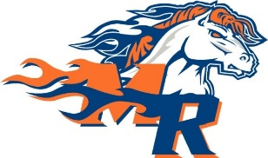
Marvin Ridge Middle School

Dear Students and Parents,

We are offering our new Tritan Tumblers brochure featuring our New Diamond Vortex Tumblers with NFL, MLB and your favorite college programs. Please offer these to your Coaches, Friends, Teachers, Relatives, Neighborhood, Church friends, and Co-workers. Send your child’s link out to 10 people! Palmetto Sports will direct ship to the customer’s house if they choose. Please do not write online orders on the order forms!

- Money should be collected at this time. Do not collect tax.
- Make checks payable to MRMS
- Each student will make 40% on each item sold, and a $20 credit towards the trip will be given to each student that sales 30 or more items!!!

Come check out FundShoppe.com and check out our best quality tumblers, great quality LOVE Bags, kitchen items, scarves, wrapping paper, and so much more!
Instructions for Fundshoppe.com
- Go to www.fundshoppe.com
- Click on "Student Registration" (Upper right hand corner)
- Enter your SCHOOL ID (__7064__)
- Enter your STUDENT ID (Located in Red at the top left corner of your order form)
- Once you register your information, our site will send you an email that includes a link to your custom fundraising site. Please forward the email to at least 10 people and share the link via social media with family and friends giving them immediate access to support your fundraising effort! The more you reach, the more you raise with FundShoppe.com.
- Over 100 products may be purchased online and shipped directly to the customer’s home.

